System verilog LAB Programs:
1.Write a SV code to demonstrate 2-state and 4-state data types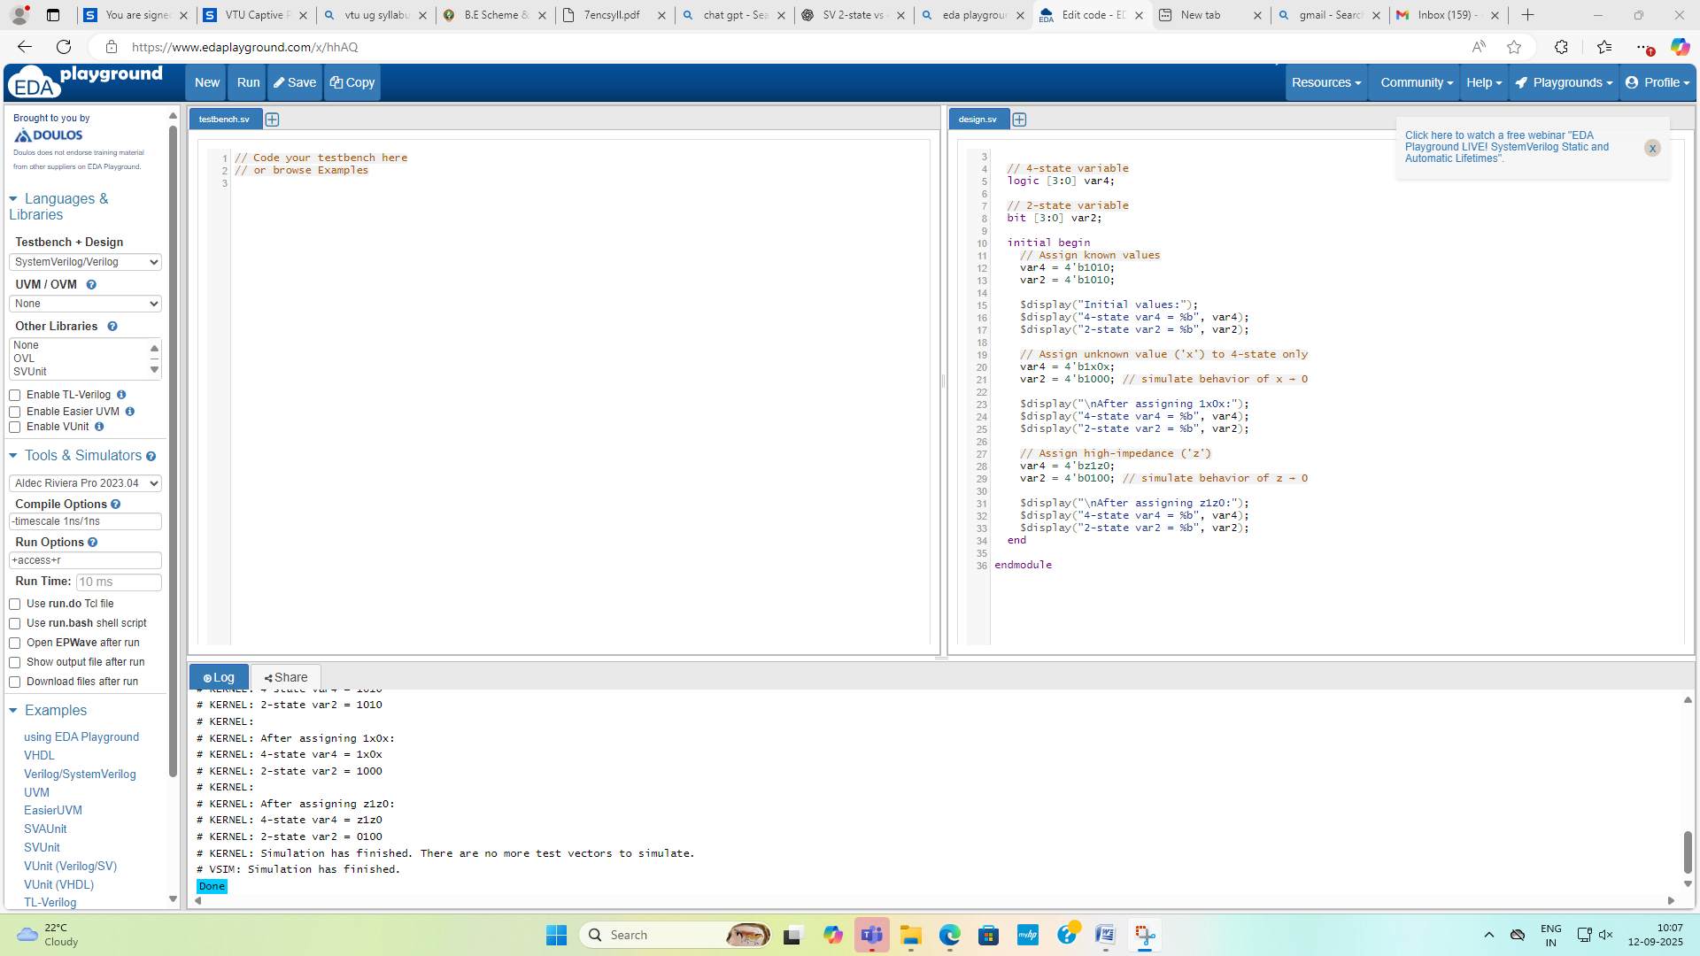

TESTBENCH
module state_demo_tb;
// Instantiate the DUT (Design Under Test)
state_demodut();
initial begin
// Record waveform for Riviera-PRO
$recordfile("waves.asdb");
$recordvars();
$display("Running testbench...");
#20;
$display("Simulation completed.");
$finish;
end
endmodule

RESULT
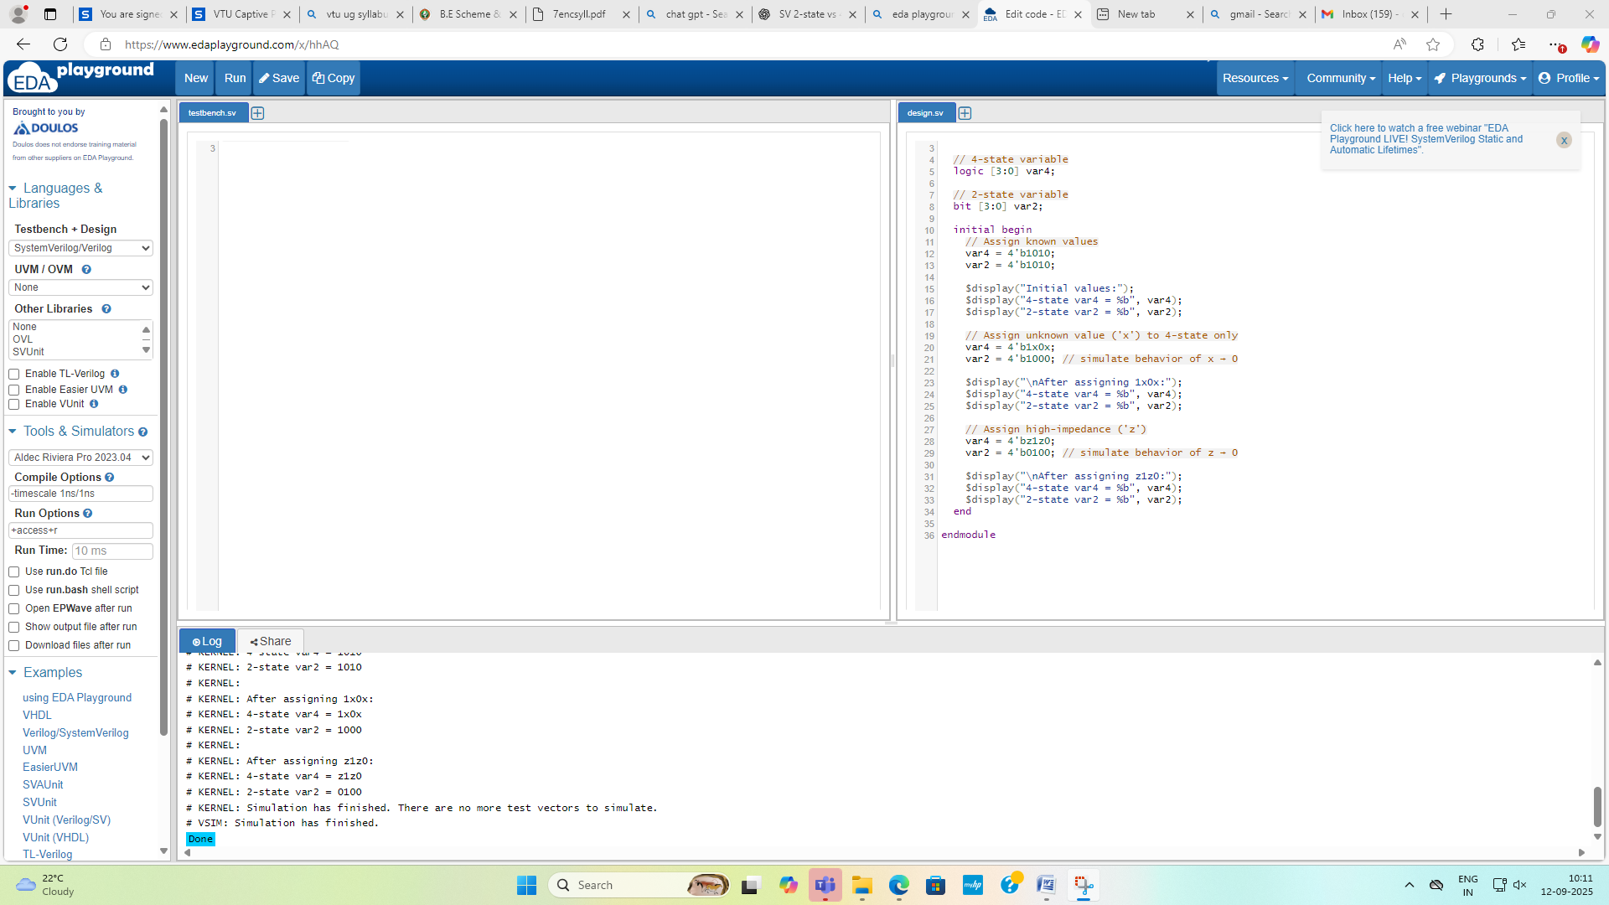
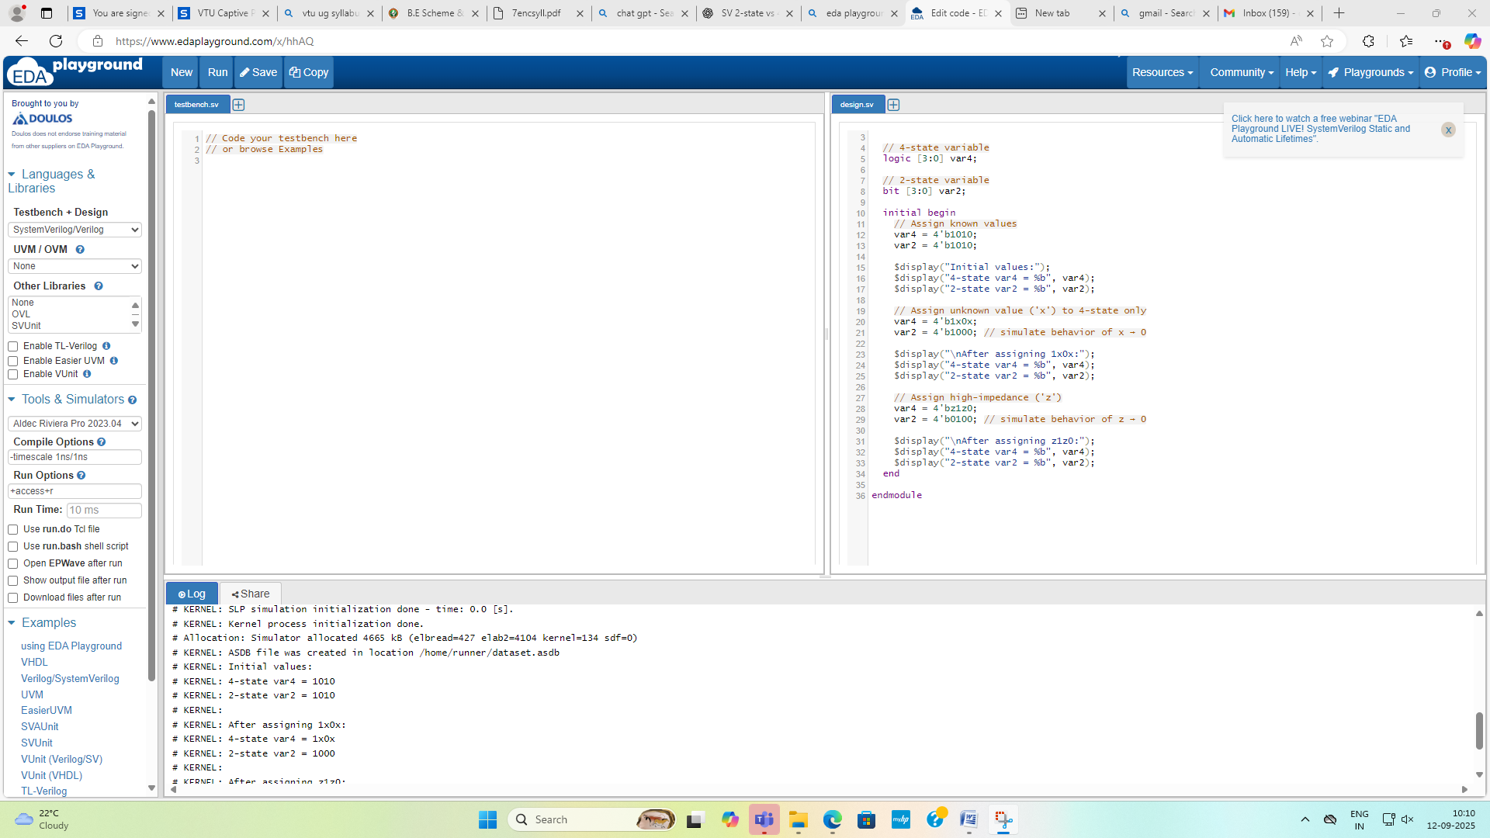

2. Write a SV code to demonstrate the difference between bit and byte.
module bit_byte_demo;
// Declare a single bit
bit my_bit;
// Declare a byte (8 bits)
byte my_byte;
initial begin
$display("=== bit vs byte demonstration ===");
// Assign values
my_bit = 1;
my_byte = 8'b1010_1100; // binary representation

$display("my_bit = %b (size = %0d bit)", my_bit, $bits(my_bit));
$display("my_byte = %b (size = %0d bits)", my_byte, $bits(my_byte));

// Show decimal equivalent of byte
$display("my_byte (decimal) = %0d", my_byte);

// Assigning a value greater than 1 to a bit will truncate
my_bit = 1'b1;
$display("\nAssigning 1 to bit: my_bit = %b", my_bit);
my_bit = 1'b0;
$display("Assigning 0 to bit: my_bit = %b", my_bit);
// Bit cannot hold multi-bit values (truncated to LSB)
my_bit = 8'b11110000;
$display("Assigning 8-bit value to bit (truncated): my_bit = %b", my_bit);
// Byte holds 8 bits
my_byte = 8'b00001111;
$display("Assigning 8-bit value to byte: my_byte = %b", my_byte);
end
endmodule
RESULT
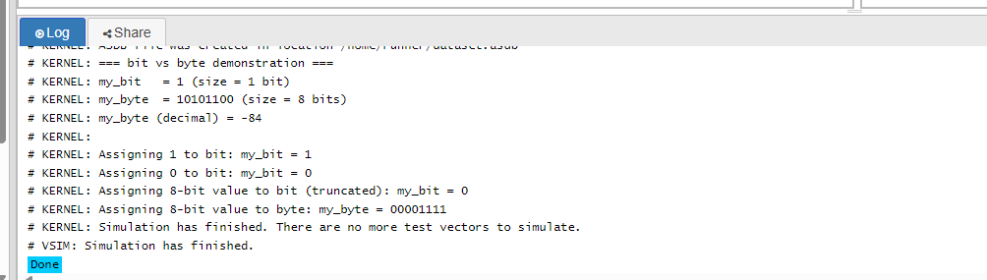

3. Write a SV code to demonstrate the difference between int and integer.
module int_vs_integer_demo;
int sv_int;
integer verilog_integer;
initial begin
// Assign positive and negative values
sv_int = -32'd100;
verilog_integer = -32'd200;
// Display the values
$display("SystemVerilog 'int' value = %0d",sv_int);
$display("Verilog 'integer' value = %0d", verilog_integer);

// Overflow behavior demonstration
sv_int = 32'hFFFFFFFF; // -1 in 32-bit signed
verilog_integer = 32'hFFFFFFFF; // -1 in 32-bitsigned
$display("After assigning 0xFFFFFFFF:");
$display("'int' as signed decimal = %0d", sv_int);
$display("'integer' as signed decimal = %0d", verilog_integer);
end
endmodule // Correct keyword to properly end the module

TEST BENCH
module int_vs_integer_demo;
int sv_int;
integer verilog_integer;
initial begin
sv_int = -32'd100;
verilog_integer = -32'd200;
$display("SystemVerilog 'int' value = %0d", sv_int);
$display("Verilog 'integer' value = %0d", verilog_integer);
sv_int = 32'hFFFFFFFF;
verilog_integer = 32'hFFFFFFFF;
$display("After assigning 0xFFFFFFFF:");
$display("'int' as signed decimal = %0d", sv_int);
$display("'integer' as signed decimal = %0d", verilog_integer);
end
endmodule

RESULT
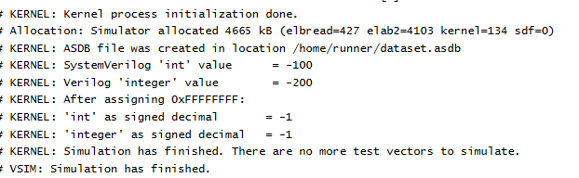
2.(a)Write a SV code to demonstrate for and foreach loops for multidimensional arrays
module array_ops;
// Declare a 2D static array of size 3x4
int matrix[3][4];
// Task to initialize array using 'for' loop
task initialize_with_for();
for (int i = 0; i< 3; i++) begin
for (int j = 0; j < 4; j++) begin
matrix[i][j] = i * 10 + j;
end
end
endtask
// Task to display array using 'foreach' loop
task display_with_foreach(string msg);
$display("=== %s ===", msg);
foreach (matrix[i, j]) begin
$display("matrix[%0d][%0d] = %0d", i, j, matrix[i][j]);
end
endtask
// Task to modify array using 'foreach' loop (e.g., double values)
task modify_with_foreach();
foreach (matrix[i, j]) begin
matrix[i][j] *= 2;
end
endtask
endmodule

TEST BENCH
`timescale 1ns / 1ps
module testbench;
// Instantiate the design module
array_opsuut(); // uut = unit under test
initial begin
// Step 1: Initialize array with 'for' loop
uut.initialize_with_for();
// Step 2: Display initial values using 'foreach'
uut.display_with_foreach("Initial values (after for-loop)");
// Step 3: Modify values using 'foreach'
uut.modify_with_foreach();
// Step 4: Display modified values
uut.display_with_foreach("Modified values (after foreach)");
$finish;
End
Endmodule
RESULT
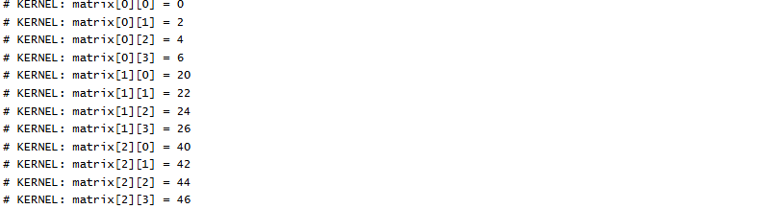

2.(b) Write a SV code to demonstrate packed and unpacked array
module packed_unpacked_example;
// Packed array: 4 elements of 8-bit logic, packed into a single vector [3:0][7:0]
logic [7:0] packed_array [3:0]; // Equivalent to: array of 4 bytes packed together
// Unpacked array: 4 separate 8-bit vectors
logic [3:0] unpacked_array [7:0]; // 8 elements, each is a 4-bit wide logic vector
initial begin
// Initialize packed array
$display("=== Packed Array Initialization ===");
for (int i = 0; i< 4; i++) begin
packed_array[i] = i * 10;
$display("packed_array[%0d] = %0d", i, packed_array[i]);
end

// Initialize unpacked array
$display("\n=== Unpacked Array Initialization ===");
for (int i = 0; i< 8; i++) begin
unpacked_array[i] = i;
$display("unpacked_array[%0d] = %0d", i, unpacked_array[i]);
end
// Show bit-level of packed array
$display("\n=== Bit-level Representation of Packed Array Elements ===");
for (int i = 0; i< 4; i++) begin
$display("packed_array[%0d] = %b", i, packed_array[i]);
end
// Show bit-level of unpacked array
$display("\n=== Bit-level Representation of Unpacked Array Elements ===");
for (int i = 0; i< 8; i++) begin
$display("unpacked_array[%0d] = %b", i, unpacked_array[i]);
end
$finish;
end
endmodule

TEST BENCH
`timescale 1ns/1ps
module testbench;
// Instantiate DUT here and your test logic
initial begin
$display("Test started");
#10;
$display("Test finished");
$finish;
end
endmodule
RESULT
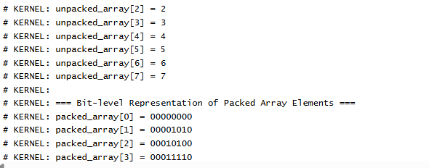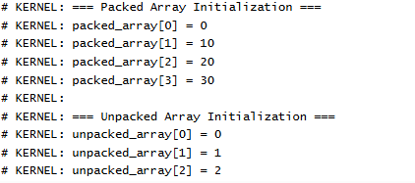
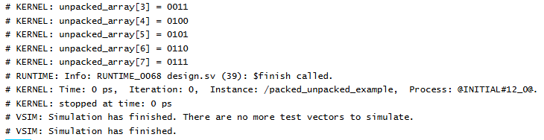

3(a) Write a SV code to implement a module to store and display a list of student grades using a dynamic array.

// Dynamic array to store grades
Module_student_grade
int grades[]; // dynamic array of integers

// Task to add grades
task add_grades(input int grade_list[], input int count);
grades = new[count]; // allocate memory
foreach (grade_list[i]) begin
grades[i] = grade_list[i];
end
endtask

// Task to display grades
task display_grades();
$display("List of Student Grades:");
foreach (grades[i]) begin
$display("Student %0d: Grade = %0d", i+1, grades[i]);
end
endtask

// Initial block to simulate behavior
initial begin
int temp_grades[] = '{85, 90, 78, 92, 88}; // Sample grades
int num_students = temp_grades.size();

// Add and display grades
add_grades(temp_grades, num_students);
display_grades();
end

endmodule

TEST BENCH
module tb_student_grades;

// Instantiate the DUT (Device Under Test)
student_gradesdut(); // No ports, simple instantiation

initial begin
$display("Starting Student Grades Testbench...\n");

// Wait for the DUT to complete (simulation happens in its initial block)
#10;

$display("\nTestbench completed.");
$finish;
end

endmodule
// Code your design here
module StudentGrades;

int grades[]; // dynamic array

// Initialize dynamic array
initial begin
grades = new[0];
end

// Task to add a grade
task add_grade(input int grade);
endtask

// Task to display all grades
task display_grades();
if (grades.size() == 0) begin
$display("No grades available.");
end else begin
$display("Student Grades:");
for (int i = 0; i < grades.size(); i++) begin
$display("Grade[%0d] = %0d", i, grades[i]);
end
end
endtask

endmodule

module testbench;

StudentGrades dut();

initial begin
dut.add_grade(85);
dut.add_grade(90);
dut.add_grade(78);

dut.display_grades();

$finish;
end

endmodule
3.b) ) Develop a module that maps product names to their prices using associative array

module ProductPriceMap;

// Associative array mapping product names (string) to prices (real)
// You can use int or real for price depending on requirement.
real prices[string];

// Task to add or update a product price
task add_product(string product_name, real price);
prices[product_name] = price;
endtask

// Task to get price of a product
function real get_price(string product_name);
if (prices.exists(product_name)) begin
return prices[product_name];
end else begin
$display("Product \"%s\" not found!", product_name);
return -1.0; // Indicate not found
end
endfunction

// Task to display all products and their prices
task display_all();
if (prices.num() == 0) begin
$display("No products available.");
end else begin
$display("Product Price List:");
foreach (prices[name]) begin
$display("%s : $%0.2f", name, prices[name]);
end
end
endtask

endmodule

Testbench
// Testbench to demonstrate
module testbench;

ProductPriceMap ppm();

initial begin
ppm.add_product("Apple", 0.99);
ppm.add_product("Banana", 0.59);
ppm.add_product("Orange", 1.25);

ppm.display_all();

$display("Price of Banana: $%0.2f", ppm.get_price("Banana"));
$display("Price of Mango: $%0.2f", ppm.get_price("Mango"));

$finish;
end

endmodule

RESULT

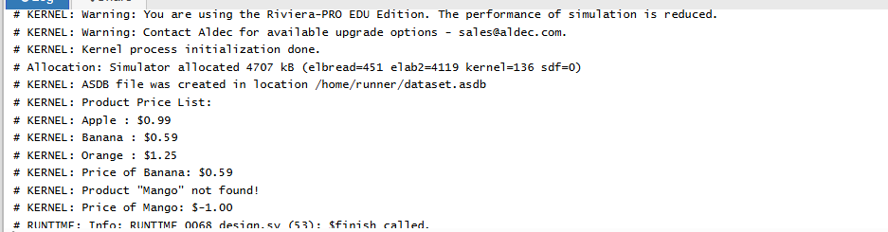

3.c) Write a SV code to demonstrate all the Queue operations.

module QueueOperations;

int queue[$]; // queue declaration
int front_element; // declare variables at module scope
int back_element;

initial begin
$display("Queue operations demonstration:");

// 1. Enqueue elements (push_back)
queue.push_back(10);
queue.push_back(20);
queue.push_back(30);
$display("After push_back 10,20,30: %p", queue);

// 2. Dequeue element from front (pop_front)
front_element = queue.pop_front();
$display("After pop_front (removed %0d): %p", front_element, queue);

// 3. Enqueue element at front (push_front)
queue.push_front(5);
$display("After push_front 5: %p", queue);

// 4. Dequeue element from back (pop_back)
back_element = queue.pop_back();
$display("After pop_back (removed %0d): %p", back_element, queue);

// 5. Access element by index
$display("Element at index 0: %0d", queue[0]);

// 6. Insert element at specific index
queue.insert(1, 15); // Insert 15 at index 1
$display("After insert 15 at index 1: %p", queue);

// 7. Delete element at specific index
queue.delete(0); // Delete element at index 0
$display("After delete element at index 0: %p", queue);

// 8. Size of queue
$display("Queue size: %0d", queue.size());

// 9. Check if queue is empty
$display("Is queue empty? %s", (queue.size() == 0) ? "Yes" : "No");

// 10. Clear the queue
queue.delete();
$display("After clearing queue: %p (size=%0d)", queue, queue.size());

$finish;
end

endmodule

RESULT
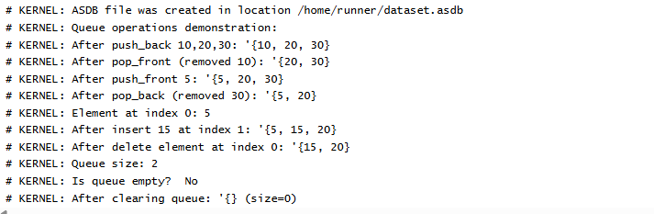

4.a) Write a SV code to demonstrate break and continue statements

module BreakContinueDemo;

initial begin
$display("Demonstrate 'continue':");

// Loop from 1 to 10
for (int i = 1; i <= 10; i++) begin
if (i % 2 == 0) begin
// Skip even numbers
continue;
end
$display("Odd number: %0d", i);
end

$display("\nDemonstrate 'break':");

// Loop from 1 to 10
for (int i = 1; i <= 10; i++) begin
if (i > 5) begin
// Exit loop if i > 5
break;
end
$display("Value: %0d", i);
end

$finish;
end

endmodule

RESULT
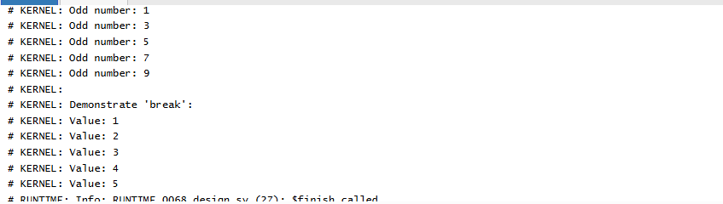

4.b) Develop a module to demonstrate Tasks, Functions and Void Function.

module TasksFunctionsDemo;

// Declare variables at module scope
integer val;
integer val_sq;

// Task: Can have input/output, can contain delays
task print_message(input string msg);
$display("Task: %s", msg);
endtask

// Function: Returns integer, no delays allowed
function integer square(input integer x);
square = x * x;
endfunction

// Void function: No return value
function void display_sum(input integer a, input integer b);
integer sum;
sum = a + b;
$display("Void function: Sum of %0d and %0d is %0d", a, b, sum);
endfunction

initial begin
// Call task
print_message("Hello from task");

// Initialize variables declared at module level
val = 5;
val_sq = square(val);
$display("Function: Square of %0d is %0d", val, val_sq);

// Call void function
display_sum(10, 20);

$finish;
end

endmodule

RESULT
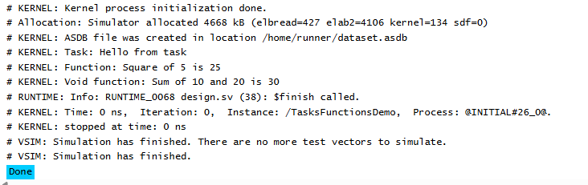

5.a) Write a SV code to demonstrate rand and randc with random class.
// Code your design here
class RandomExample;

// 'rand' — normal random variable (values can repeat)
rand bit [3:0] rand_val;

// 'randc' — cyclic random variable (values do not repeat until all used)
randc bit [3:0] randc_val;

// Optional constraints (limit value range)
constraint val_range {
rand_val inside {[0:9]}; // restrict rand_val to 0–9
randc_val inside {[0:9]}; // restrict randc_val to 0–9
}

// Display results
function void display();
$display("rand_val = %0d, randc_val = %0d", rand_val, randc_val);
endfunction

endclass

Testbench
module tb;
RandomExample obj;

initial begin
obj = new();
$display("=== Demonstrating rand and randc ===");
$display(" rand → may repeat values");
$display(" randc → cycles through values without repetition\n");

// Run randomization multiple times
repeat (15) begin
if (obj.randomize()) begin
obj.display();
end else begin
$display("Randomization failed!");
end
end

$finish;
end

endmodule

Result
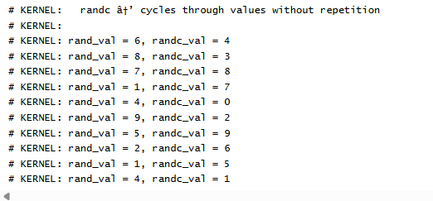
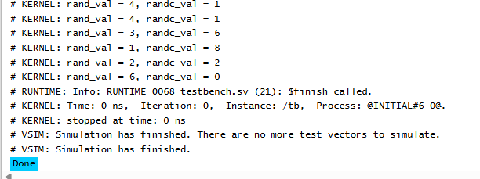
5.b) Write a constraint for removing duplicate elements from queue.
class UniqueQueueExample;

// Declare a random queue of integers
rand int q[$];

// Size constraint
constraint size_c {
q.size() == 5; // Queue will always have 5 elements
}
⁸
// Uniqueness constraint
constraint unique_c {
unique { q }; // Ensures all queue elements are unique
}

// Value range constraint (optional)
constraint range_c {
foreach (q[i]) q[i] inside {[1:10]}; // Each element between 1–10
}

// Display method
function void display();
$display("Unique queue = %p", q);
endfunction

endclass

Test bench
module tb;
UniqueQueueExample obj;

initial begin
obj = new();

$display("=== Demonstrating constraint to remove duplicates from queue ===\n");

// Try randomizing multiple times
repeat (5) begin
if (obj.randomize()) begin
obj.display();
end else begin
$display("Randomization failed!");
end
end

$finish;
end

endmodule

Result
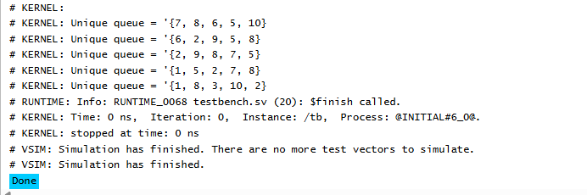

5.c) ) Write a constraint to generate even numbers between 10 to 30.
class EvenNumberGenerator;

rand int num; // Random variable

// Constraint block to restrict range and ensure even numbers
constraint even_range {
num inside {[10:30]}; // Range between 10 and 30
num % 2 == 0; // Must be even
}

endclass

module even_numbers_constraint;

EvenNumberGenerator eng = new();

initial begin
$display("Random even numbers between 10 and 30:");
repeat (10) begin
assert(eng.randomize()) else $error("Randomization failed!");
$display("%0d", eng.num);
end
end

endmodule

RESULT
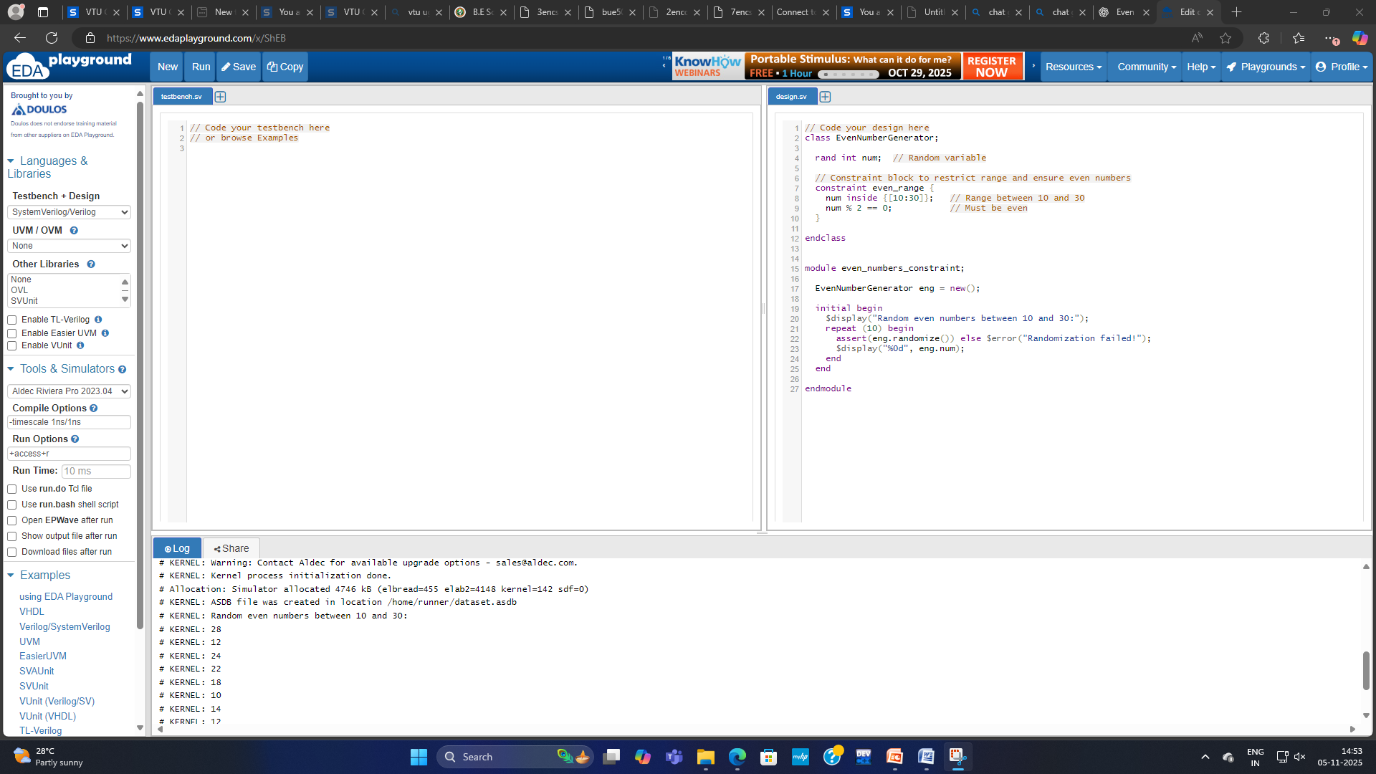
6.a) Write a constraint to arrange the initial numbers in ascending order and remaining numbers in descending order.
// Code your design here
class OrderArray;

rand int arr[]; // dynamic array

// Constraint: size of the array and ordering
constraint c_arr_size { arr.size() == 10; } // example size = 10

// Constraint to arrange:
// - first half ascending
// - second half descending
constraint c_order {
foreach (arr[i]) {
// Ascending order for first half
if (i < arr.size()/2 - 1)
arr[i] < arr[i+1];

// Descending order for second half
if (i >= arr.size()/2 && i < arr.size()-1)
arr[i] > arr[i+1];
}
}

endclass

Testbench
module tb_order_array;

OrderArray obj = new();

initial begin
assert(obj.randomize()) else $error("Randomization failed!");

$display("Array with first half ascending and second half descending:");
foreach (obj.arr[i])
$write("%0d ", obj.arr[i]);
$display(""); // newline
end

endmodule

Result
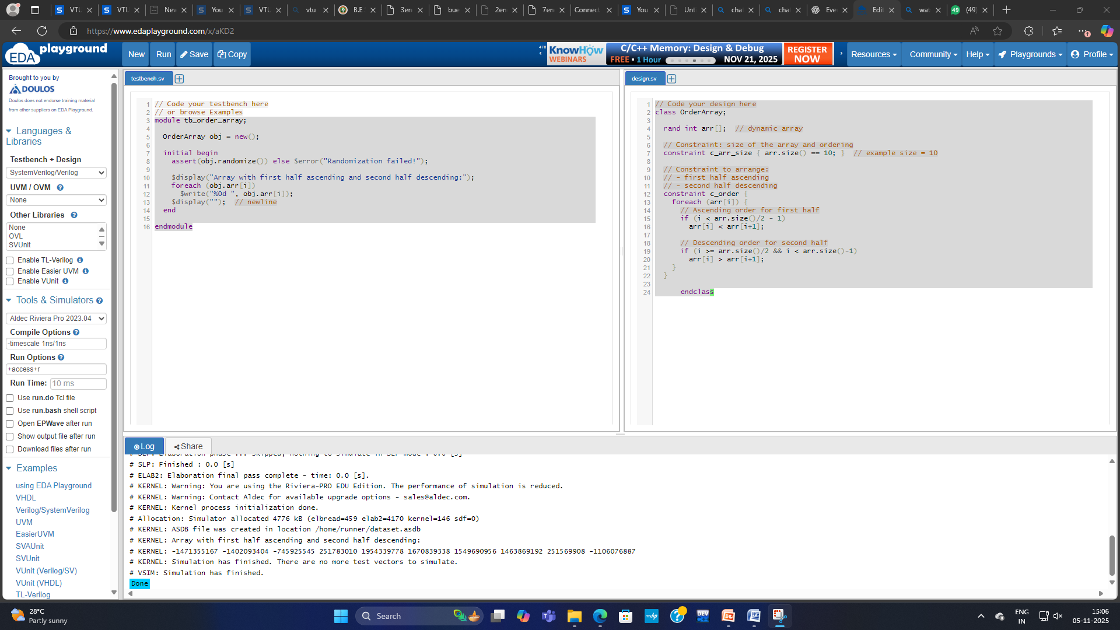

6.b) Write a constraint to generate a sequence of 9 99 999 9999 99999.
class SequenceGen;
rand int arr[];

// fix the size to 5
constraint size_c { arr.size() == 5; }

// enforce the sequence: arr[0] == 9; arr[i] == arr[i-1]*10 + 9
constraint pattern_c {
arr[0] == 9;
foreach (arr[i]) if (i > 0) arr[i] == arr[i-1] * 10 + 9;
}
endclass

Testbench
module tb_sequence_gen;
SequenceGen sg = new();

initial begin
// randomize the array (but constraints force exact values)
if (!sg.randomize()) begin
$error("randomize() failed");
$finish;
end

$display("Constrained sequence (SystemVerilog):");
foreach (sg.arr[i]) $display("%0d: %0d", i, sg.arr[i]);

$finish;
end
endmodule

Result
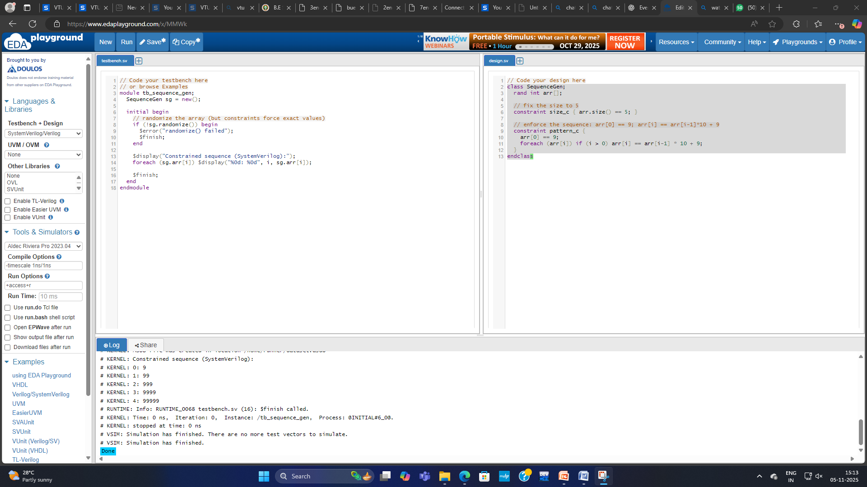

7.a) Write a constraint to generate:
- A queue with unique value.
class unique_queue_gen;
rand int q[]; // Declare a random queue of integers
rand int size; // Random queue size

constraint c_size {
size inside {[5:10]}; // Queue size between 5 and 10
}

constraint c_unique {
q.size() == size; // Queue must match the chosen size
unique { q }; // All elements in the queue must be unique
}

// Optional: limit the range of values
constraint c_values {
foreach (q[i]) q[i] inside {[0:50]};
}

function void display();
$display("Unique Queue (size=%0d): %p", q.size(), q);
endfunction
endclass

module test;
initial begin
unique_queue_gen gen = new();

// Try multiple randomizations
repeat (5) begin
if (gen.randomize())
gen.display();
else
$display("Randomization failed!");
end
end
endmodule

RESULT
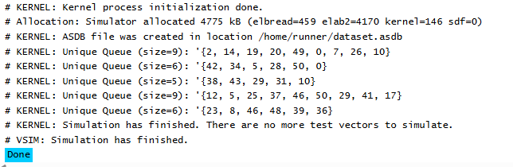

- Store a even number at the index of the odd value.
class even_at_odd_index;
rand int arr[]; // random array
rand int size; // size of the array

constraint c_size {
size inside {[5:10]}; // array size between 5 and 10
arr.size() == size;
}

// Constraint: Even number at the index equal to an odd value
constraint c_even_at_odd_index {
foreach (arr[i]) {
// If index 'i' is odd, arr[i] must be even
if (i % 2 == 1)
arr[i] % 2 == 0;
else
arr[i] % 2 == 1; // (optional) make even indices store odd numbers
}
}

// Limit the range of the values (optional)
constraint c_range {
foreach (arr[i])
arr[i] inside {[0:50]};
}

function void display();
$display("Array (size=%0d): %p", arr.size(), arr);
endfunction
endclass

module test;
initial begin
even_at_odd_index obj = new();

repeat (5) begin
if (obj.randomize())
obj.display();
else
$display("Randomization failed!");
end
end
endmodule

RESULT
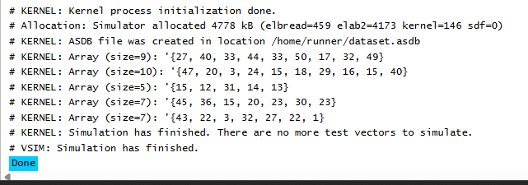

- Store a odd number at the index of the even value
class odd_at_even_index;
rand int arr[]; // Random array
rand int size; // Size of array

// Constraint: array size between 5 and 10
constraint c_size {
size inside {[5:10]};
arr.size() == size;
}

// Main constraint:
// Store an odd number at every even index
constraint c_odd_at_even_index {
foreach (arr[i]) {
if (i % 2 == 0)
arr[i] % 2 == 1; // odd value at even index
else
arr[i] % 2 == 0; // optional: even value at odd index
}
}

// Optional: Limit the value range
constraint c_range {
foreach (arr[i])
arr[i] inside {[0:50]};
}

// Display function
function void display();
$display("Array (size=%0d): %p", arr.size(), arr);
endfunction
endclass

module test;
initial begin
odd_at_even_index obj = new();

// Generate multiple examples
repeat (5) begin
if (obj.randomize())
obj.display();
else
$display("Randomization failed!");
end
end
endmodule

RESULT
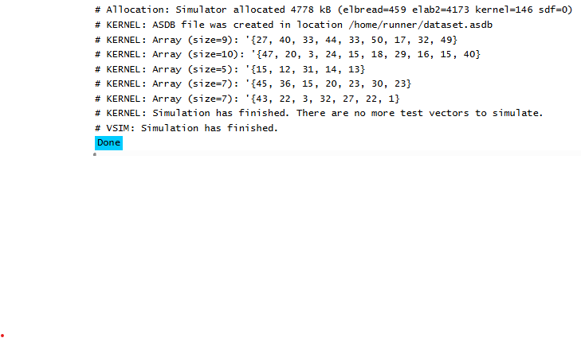
7.b) Write a constraint to generate a pattern of 000111222333444555
class pattern_gen;
rand int arr[]; // dynamic array to hold the pattern

// Constraint to generate the pattern 000111222333444555
constraint c_pattern {
arr.size() == 18; // total 18 elements (6 groups × 3 repeats)

foreach (arr[i]) {
arr[i] == (i / 3); // every 3 elements have the same number
}
}

// Display
function void display();
$display("Generated Pattern: %p", arr);
endfunction
endclass

module test;
initial begin
pattern_gen obj = new();

if (obj.randomize())
obj.display();
else
$display("Randomization failed!");
end
endmodule

RESULT
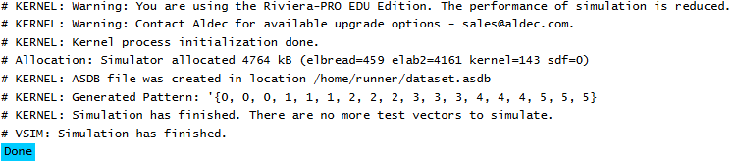

8.a) Demonstrate fork-join, for-join-any, fork-join-none using suitable SV code.
module fork_join_demo;

// Simple tasks to simulate concurrent work
task automatic task_A();
$display("[%0t] Task A started", $time);
#10;
$display("[%0t] Task A finished", $time);
endtask

task automatic task_B();
$display("[%0t] Task B started", $time);
#20;
$display("[%0t] Task B finished", $time);
endtask

task automatic task_C();
$display("[%0t] Task C started", $time);
#30;
$display("[%0t] Task C finished", $time);
endtask

// ----------------------------------------------------------
// fork...join → waits for all threads to finish
// ----------------------------------------------------------
initial begin
$display("\n=== Example 1: fork...join ===");
fork
task_A();
task_B();
task_C();
join
$display("[%0t] All tasks finished → continuing (fork-join)\n", $time);
end

// ----------------------------------------------------------
// fork...join_any → waits until *any one* thread finishes
// ----------------------------------------------------------
initial begin
#50; // delay to separate examples
$display("\n=== Example 2: fork...join_any ===");
fork
task_A();
task_B();
task_C();
join_any
$display("[%0t] One of the tasks finished → continuing (fork-join_any)\n", $time);
#40; // let others finish for clarity
end

// ----------------------------------------------------------
// fork...join_none → does not wait at all
// ----------------------------------------------------------
initial begin
#120; // delay to separate examples
$display("\n=== Example 3: fork...join_none ===");
fork
task_A();
task_B();
task_C();
join_none
$display("[%0t] Main thread continues immediately (fork-join_none)\n", $time);
#40; // wait to observe other threads
$display("[%0t] End of simulation\n", $time);
end

endmodule

RESULT
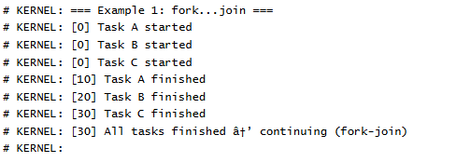
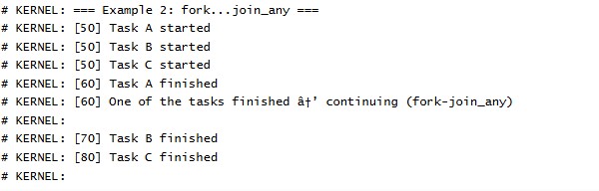
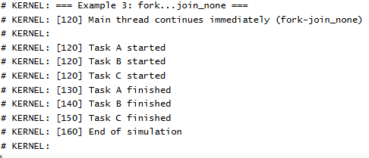

8.b) Develop module of the mailbox connecting two transactors.
`timescale 1ns/1ps

// Simple transaction object
class txn;
rand int unsigned id;
rand bit [31:0] data;

function new(int unsigned id = 0, int unsigned data = 0);
this.id = id;
this.data = data;
endfunction

function string to_string();
return $sformatf("{id=%0d data=0x%0h}", id, data);
endfunction
endclass

// Producer transactor: generates transactions and puts them onto the mailbox
class producer_tx;
mailbox #(txn) mb; // typed mailbox handle
int unsigned num_to_send;
int unsigned delay_ns; // optional inter-transaction delay (ns)

function new(mailbox #(txn) mb, int unsigned n = 10, int unsigned d = 10);
this.mb = mb;
this.num_to_send = n;
this.delay_ns = d;
endfunction

task run();
txn t;
for (int unsigned i = 1; i <= num_to_send; i++) begin
// create a transaction and randomize its fields (optional)
t = new(i, $urandom());
if (!t.randomize()) begin
// ignore randomize failure; it's optional
end

// blocking put: if mailbox full, this will wait
$display("[%0t] Producer: putting txn %s", $time, t.to_string());
mb.put(t);

// optional delay between transactions to emulate timing
#delay_ns;
end

// send a null/poison-pill to indicate end of stream (consumer should detect)
$display("[%0t] Producer: sending end-of-stream marker", $time);
mb.put(null);
endtask
endclass

// Consumer transactor: gets transactions from mailbox and processes them
class consumer_tx;
mailbox #(txn) mb;
int unsigned processed = 0;

function new(mailbox #(txn) mb);
this.mb = mb;
endfunction

task run();
txn t;
forever begin
// blocking get: waits until something is available
mb.get(t);

// check for "end of stream" marker (null pointer)
if (t == null) begin
$display("[%0t] Consumer: received end-of-stream marker, processed=%0d. Exiting.",
$time, processed);
break;
end

// process the transaction
processed++;
$display("[%0t] Consumer: got txn %s (processed=%0d)", $time, t.to_string(), processed);

// emulate processing time
#5;
end
endtask
endclass

Testbench
module tb_mailbox;
// typed mailbox of txn objects; size parameter is optional (0=unbounded),
// here we create a mailbox with depth 4 for demonstration (bounded)
mailbox #(txn) mb = new(4);

// instances
producer_tx prod;
consumer_tx cons;

initial begin
$display("=== Mailbox transactors demo ===");

// create transactors
prod = new(mb, 12, 7); // send 12 txns, 7ns gap
cons = new(mb);

// launch producer and consumer concurrently
fork
prod.run();
cons.run();
join_any

// wait for both to finish: we expect consumer to exit after reading null
// However join_any returns when first finishes; ensure both are done:
// Use a small loop to poll mailbox/processed state or simply wait long enough.
// For clarity we will wait until consumer posts the end-of-stream message and then finish.
// A robust environment would coordinate using events or a join of the processes.

// Give enough time for final prints, then finish simulation
#200;
$display("=== Simulation complete ===");
$finish;
end
endmodule

Output
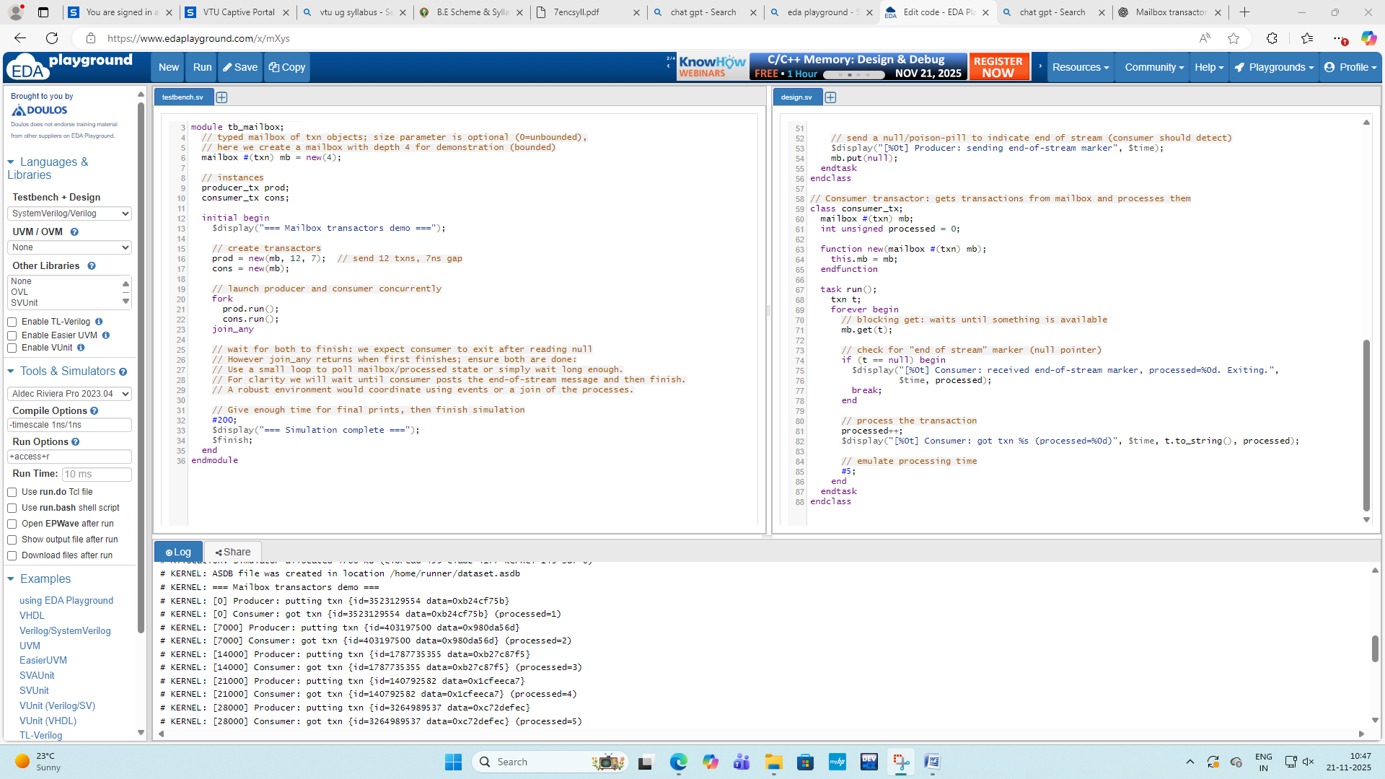

DEMO EXPERIMENT
9) Demonstrate complete SV design that incorporates the entire SystemVerilog environment for simple digital circuit.
interface intf(input bit clk);
logic a, b, y; // simple AND gate DUT signals
endinterface
module dut(intf i);
assign i.y = i.a & i.b;
endmodule
class transaction;
rand bit a, b;
bit y; // expected output

function void display(string tag);
$display("[%s] a=%0b b=%0b y=%0b", tag, a, b, y);
endfunction
endclass
class generator;
mailbox gen2drv;
int num;

function new(mailbox m, int n);
gen2drv = m;
num = n;
endfunction

task run();
transaction t;
repeat(num) begin
t = new();
assert(t.randomize());
t.display("GEN");
gen2drv.put(t);
end
endtask
endclass
class driver;
virtual intf vif;
mailbox gen2drv, drv2mon;

function new(virtual intf v, mailbox m1, mailbox m2);
vif = v;
gen2drv = m1;
drv2mon = m2;
endfunction

task run();
transaction t;
forever begin
gen2drv.get(t); // safe → always object (no null)
t.display("DRV");
vif.a = t.a;
vif.b = t.b;
#10;
drv2mon.put(t);
end
endtask
endclass
class monitor;
virtual intf vif;
mailbox drv2mon;

function new(virtual intf v, mailbox m);
vif = v;
drv2mon = m;
endfunction

task run();
transaction t;
forever begin
drv2mon.get(t); // safe → driver always sends
t.y = vif.y;
t.display("MON");
end
endtask
endclass
class environment;
generator gen;
driver drv;
monitor mon;

mailbox gen2drv = new();
mailbox drv2mon = new();

virtual intf vif;

function new(virtual intf v);
vif = v;
gen = new(gen2drv, 5);
drv = new(vif, gen2drv, drv2mon);
mon = new(vif, drv2mon);
endfunction

task run();
fork
gen.run();
drv.run();
mon.run();
join_any
$display("ENV DONE");
endtask
endclass

Testbench
module tb;
bit clk = 0;
always #5 clk = ~clk;

intf i(clk);
dut d(i);

environment env;

initial begin
env = new(i); // IMPORTANT → avoids NULL POINTER
env.run();
#100 $finish;
end
endmodule

Output
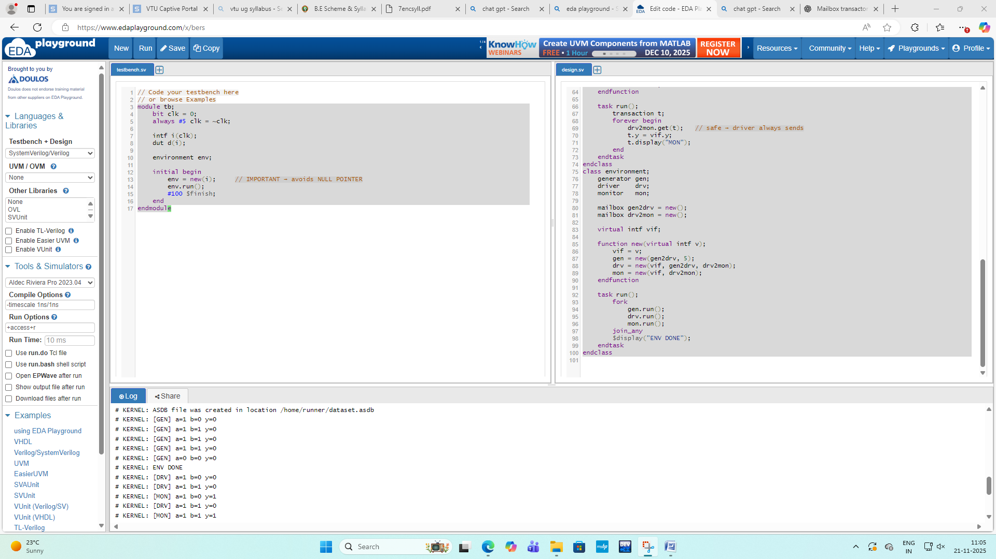

10) Demonstrate simple protocol through the SV environment.
// Code your design here
interface proto_if(input logic clk);
logic req;
logic ack;
endinterface
module proto_dut(
input logic clk,
input logic rst,
input logic req,
output logic ack
);
int delay_cnt = 0;

always_ff @(posedge clk or posedge rst) begin
if (rst) begin
ack <= 0;
delay_cnt <= 0;
end else begin
if (req) begin
delay_cnt <= 2; // respond in 2 cycles
end else if (delay_cnt > 0) begin
delay_cnt <= delay_cnt - 1;
end

ack <= (delay_cnt == 1);
end
end
endmodule
module driver(
input logic clk,
input logic rst,
output logic req
);

initial begin
req = 0;
@(negedge rst);

repeat (5) begin
@(posedge clk);
req <= $urandom_range(0,1);
$display("[DRV] Time=%0t req=%0b", $time, req);
end
end
endmodule
module monitor(
input logic clk,
input logic req,
input logic ack
);

always @(posedge clk) begin
$display("[MON] Time=%0t req=%0b ack=%0b", $time, req, ack);
end
endmodule

Testbench
module tb;

logic clk = 0;
logic rst = 1;

always #5 clk = ~clk;

proto_if pif(clk);

proto_dut dut(
.clk(clk),
.rst(rst),
.req(pif.req),
.ack(pif.ack)
);

driver drv(
.clk(clk),
.rst(rst),
.req(pif.req)
);

monitor mon(
.clk(clk),
.req(pif.req),
.ack(pif.ack)
);

initial begin
#15 rst = 0;
#200 $finish;
end

endmodule

Output
